IBPOC Network Justification Letter

Looking to communicate the value of attending our IBPOC Network networking sessions and workshops to management and/or your team? We’ve created this letter to help you do so!

Dear <supervisor or colleague’s name>,

I would like to attend an IBPOC Network Tea and Talk or online workshop on <insert date>.

This session is offered by the BC Museums Association for free, and thus provides a professional development opportunity that comes at no extra cost to this organisation.

It is considered a professional development opportunity because these sessions aim to introduce IBPOC museum, arts, and culture professionals and volunteers to each other and build relationships between them. The goal of these sessions is to create a wide-ranging peer support network between IBPOC professionals across the province that ultimately strengthens our representation in this sector and meets our diverse needs. In the case of the workshops, there is an additional goal of building specific skill sets to help IBPOC professionals navigate challenges in the workplace that pertain to our racialized positionalities.

Why is this needed? Folks who identify as Indigenous, Black, a Person of Colour, or racialized are currently underrepresented in this sector, comprising 23% of the workforce in galleries, archives, and cultural institutions (2021 Census). IBPOC workers are often the only people of racialized backgrounds on their team, and as organisations work towards accomplishing equity and inclusion goals, the majority of this labour tends to fall on IBPOC team members (whether this is intended to or not). Some of this labour may even be unpaid, as it relies upon relationship-building and processing of emotional needs and experiences that take place away from a desk setting.

These statements are informed by the numerous experiences shared by IBPOC folks in these network sessions. While we may not always feel comfortable sharing these experiences with our teams, the network sessions provide an accountable space for us to do so among peers who have lived experience of similar challenges. By creating these spaces where we can support each other and co-navigate these challenges, we are better able to return to our workplaces energised and equipped to deal with these unique issues.

Additionally, the sessions create a space where we are able to help each other combat feelings of isolation, “otherness”, and experiences of institutional racism. While these experiences may not pertain to my workplace, participating in these sessions enables me to support others in navigating these challenges. These sessions may be informal in format, but they contribute to a larger dismantling of foundational systems of oppression that we can all benefit from.

Lastly, encouraging IBPOC team members to participate in these sessions during paid work time is a very simple way to meet any equity and inclusion commitments our organisation has committed to. For it’s great to see a public statement about inclusion made, but even better to see those statements translated into accountable action, as this is.

Please support my participation in these affinity spaces, and be an ally. We all want to create a more inclusive sector that genuinely supports and cares about its racialized workers. This is the first step.

Sincerely,
<Your Name>

[FOR JAZMIN]
Copy from early IBPOC Network applications:
The BCMA has concluded that the needs of arts, culture and heritage emerging professionals, especially those who are marginalized, are urgent. In June 2020, the BCMA hosted a webinar entitled “#MuseumsAreNotNeutral: White supremacy in museums and immediate calls to action.” This webinar, led by an expert in the field of anti-racism, outlined the importance of immediately dismantling institutional and foundational racism in order to work toward truly inclusive and representative spaces. Registration for this webinar far exceeded any past registration for BCMA webinars, and the video has now gained over 4,000 views. The feedback we received was enormous, and highlights the urgency, interest, and need for action:
“THIS WAS THE MOST IMPORTANT WEBINAR I HAVE SEEN YET. Powerful and necessary.”
-#MuseumsAreNotNeutral Webinar Participant
"The topic is in my opinion one of our most pressing issues as a society"
-#MuseumsAreNotNeutral Webinar Participant
"Can't let up now. We must be proactive in building professional capacity for people in the BIPOC community. All exhibits, programs, etc. need to be led by those communities. Museum professionals are facilitators, not subject experts."
-#MuseumsAreNotNeutral Webinar Participant
Highlighted in this presentation was the need for immediate hiring and fostering the careers of people of colour within the museum sector, and putting in place mechanisms to support them. Large and small museums alike have an important role to play in telling the stories of the diverse communities they are intended to represent, but systemic and institutional racism has meant that white directors, curators, executives and other museum staff are the ones deciding which stories are told and how to tell them. This is precisely why it is crucial to move beyond entry-level jobs and support the careers of racially marginalized museum professionals, so that not only are museums more reflective of the communities they wish to represent, but that these communities have control of the narrative and education that the broader public receives.

Copy from later applications:
A theme that continues to emerge throughout discussions around equity and justice is the intense value of peer support and connection. The experience of BIPOC cultural professionals in BC is often one of isolation and “otherness”, with continued expectations to shoulder the expectations, ignorance, and apathy of their majority-white institutions.
Particularly for emerging professionals, access to a network of peers with shared experience to validate, support, and mentor can be foundational to career and mental wellness.

From Hill Strategies
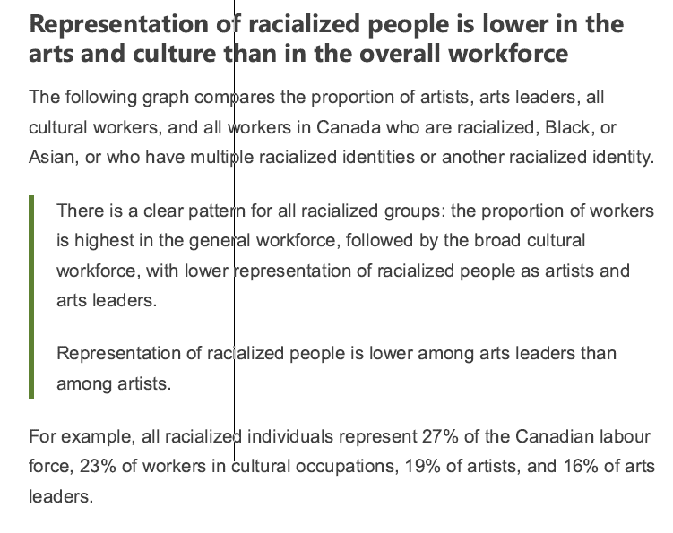
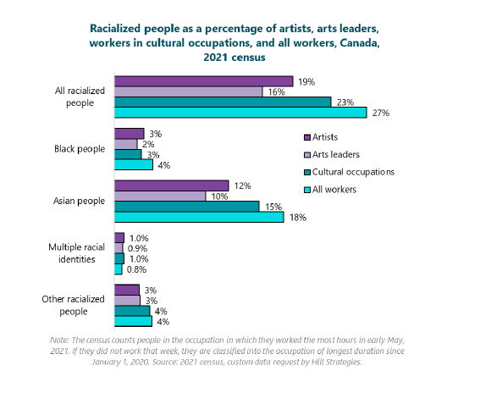

From the Museums for Me data story

The museum sector is currently grappling with the shifting role of museums as active
advocates for social change. Some museums are taking steps to address social issues
relevant to their communities in their exhibits, collections, and programs. Some museums
are hesitant to embrace the role of advocates for social change out of concern over public
expectations for museums to remain neutral. The understanding among museum staff and
volunteers that museums are not neutral is shared by some museum-goers, although not all.
Canadians were asked if specific social issues changed how they saw the role and value of
museums. Over half of respondents felt that technological and digital innovation, and
Indigenous reconciliation positively impacted how they saw the role and value of museums.
Nearly all the social issues raised elicited a positive response. Canadians clearly believe
museums have a constructive role to play in addressing social issues.
The question is not if museums should address societal issues, but how. When asked this
question, Canadians selected education, better representation of all Canadians, and
advocating for social change as the preferred ways for museums to respond. This echoes
the public perception that museums are trusted institutions that excel in preservation,
education, and storytelling, but could do more to represent their communities (see
Getting to Relevance Through Accessibility and Representation and Telling the Truth:
Trustworthiness, Learning, and Sharing Authority).

