­­­­Title­­

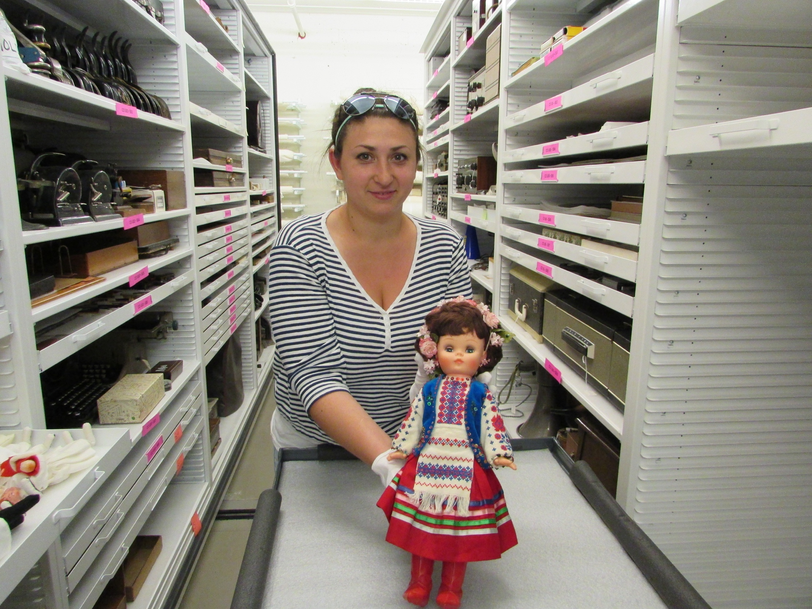Subtitle

Introduction

BodyText

Header

BodyText



Header

BodyText

Image Caption

Image credit

Quote

Image Caption

Image credit